AIR UNIVERSITY, ISLAMABAD
National Cyber Security Academy

SEMESTER PROJECT REPORT
Intelligent Secure E-Voting System (ISEVS)
Course:
Object-Oriented Programming (OOP)
Submitted By:
Noor Ul Ain Nawaz (2503807)

Contents
1. Introduction 2
Project Title: Intelligent Secure E-Voting System (ISEVS) 2
Objectives 2
Scope 2
2. System Overview 2
Administrators 3
Voters 3
3. Functional Requirements 3
Registration & Login 3
Candidate Management 3
Voting Time Window 3
Voting System 3
Results & Analytics: 3
Data Storage: 3
4. OOP Design Explanation 3
Encapsulation 4
Inheritance 4
5. UML Class Diagram 6
User (Parent Class): 6
Voter (Child Class): 6
Admin (Child Class): 6
Candidate (Separate Class): 6
6. Workflow Explanation 6
Starting Up 7
Setup (Admin): 7
Registration (Voter): 7
Login 7
Voting: 7
7. GUI Screenshots 8
Landing Page: 8
Registration Screen: 8
Voter Login: 9
Voting Panel: 10
Admin Dashboard: 10
8. Input Validation 10
Empty Inputs: 11
Password Rules 11
9. Extra Features 11
Custom Security (Salting and Hashing): 12
Data Encryption: 12
10. Conclusion 12
Future Improvements 13

1. Introduction

Project Title: Intelligent Secure E-Voting System (ISEVS)
Problem Statement: Traditional physical voting systems have a lot of issues. They can be slow, hard to manage, and are sometimes open to cheating or human error. Even some digital voting systems lack the proper security to protect voter data. There is a need for a secure, computerized voting system that makes sure the election is fair, keeps voter data private, and guarantees that no one can vote more than once.

Objectives:
- To build a secure digital voting system using Object-Oriented Programming (OOP) in C++.
- To make sure the "one person, one vote" rule is strictly followed by verifying CNIC numbers.
- To protect user passwords and personal data using hashing and encryption.
- To give voters a receipt ID so they have proof they voted, without revealing who they voted for.

Scope:
This project covers the main steps of an election. It allows Administrators to manage the system (like adding candidates and setting the time for voting) and allows Voters to securely register, log in, and cast their ballots.

2. System Overview
Our system is designed with a strong backend engine and a modern frontend prototype. The backend is written entirely in C++. This is where all the actual processing happens—it uses OOP to manage users, handles the encryption for security, and saves all the data into text files so nothing is lost when the program closes.
To show how the final product should look, we also designed a Graphical User Interface (GUI) prototype using HTML, CSS, and JavaScript.

The system is made for two main types of users:
- Administrators: These are the election officials. They have a special dashboard to set up the election, manage the candidate list, and see the live voting results.
- Voters: These are the normal citizens. They use the system to register with their CNIC, securely log in, view the candidates, and cast their one allowed vote.

3. Functional Requirements
We implemented several core features to make the system work properly:
- Registration & Login: Both admins and voters can create accounts and securely log in.
- Candidate Management: Admins can add, edit, or remove candidates from the election.
- Voting Time Window: Admins can set a specific start and end time (in 24-hour format) for the election. Voters can only cast ballots during this time.
- Voting System: Voters can choose a candidate and submit their vote. The system immediately marks them as "voted" so they can't vote again.
- Results & Analytics: The system automatically counts the votes and generates charts to show which candidate is winning.
- Data Storage: The system automatically saves and loads all user and vote data using file handling (fstream) in C++.

4. OOP Design Explanation
Since this project is based on Object-Oriented Programming, we used several OOP concepts to keep our code clean and secure:
- Encapsulation: We kept sensitive data safe by making variables like passwords, CNIC numbers, and salts private or protected inside our classes. This means outside code cannot accidentally change or read a user's password. To access or update this data, we created specific public methods (getters and setters) like verifyLogin() and getName().
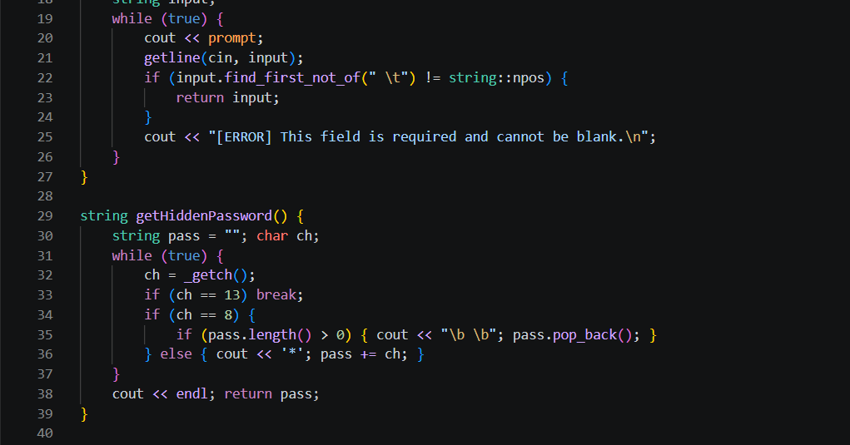
Inheritance: Instead of writing the same code multiple times, we created a base class called User. This class holds the basic details that everyone has, like name, gender, and password. Then, we created Voter and Admin classes that inherit from User. The Voter class adds specific things like a hasVoted status, while the admin class adds an area status. 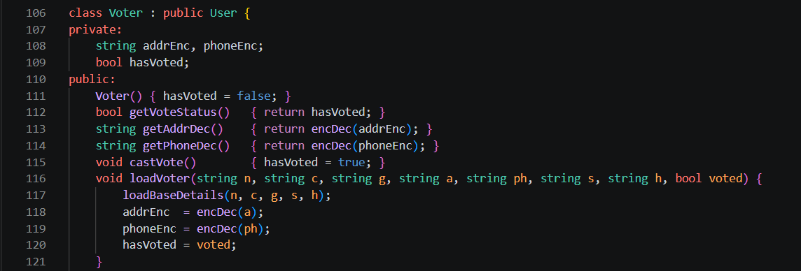
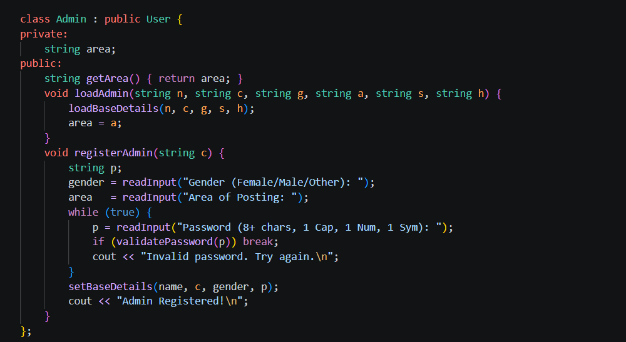

5. UML Class Diagram
- User (Parent Class): Contains variables like name, cnicEnc, passHash and methods like verifyLogin().
- Voter (Child Class): Point an inheritance arrow to User. Contains variables like hasVoted and methods like castVote().
- Admin (Child Class): Point an inheritance arrow to User. Contains variables like area and methods like registerAdmin().
- Candidate (Separate Class): Contains variables like name, party, voteCount and methods like addVote().
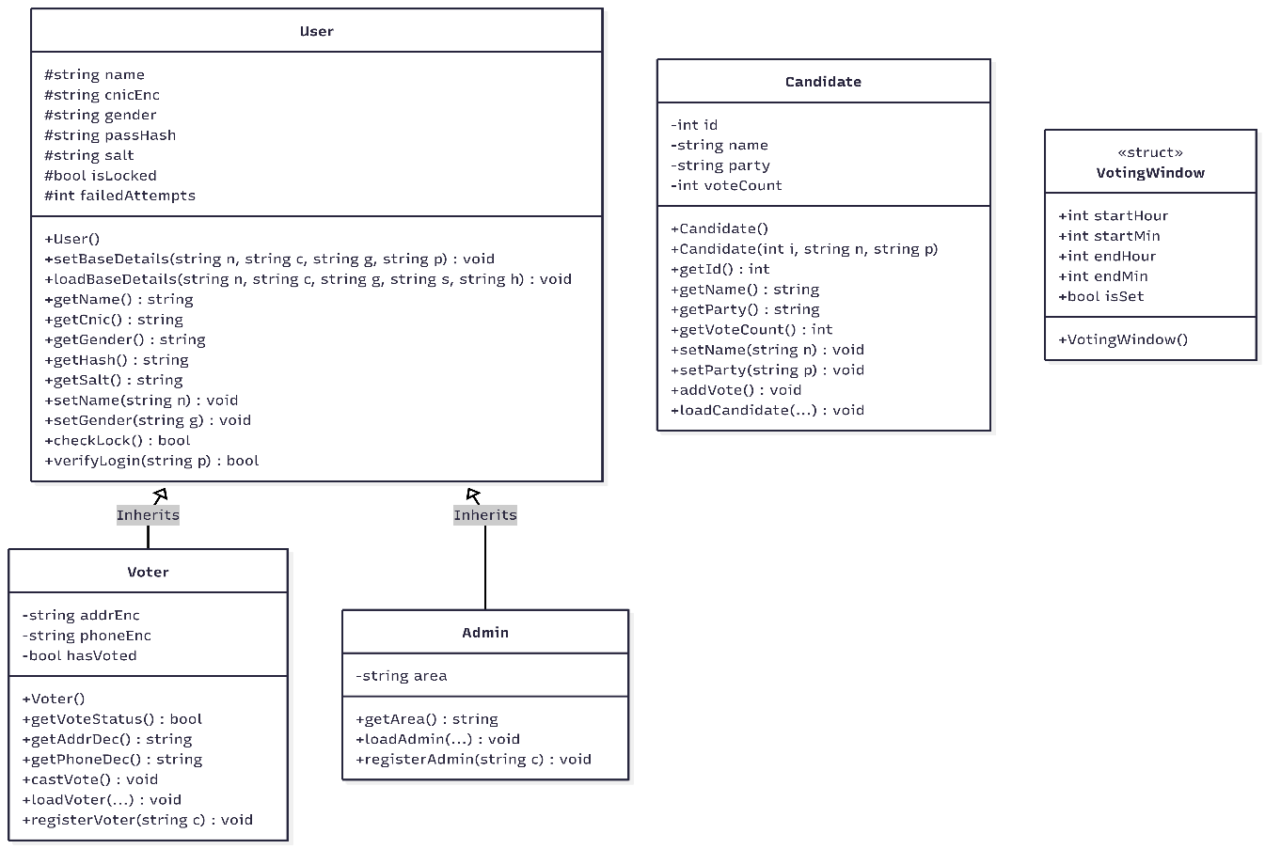

6. Workflow Explanation
Here is the step-by-step user flow of how the system operates:
- Starting Up: When the program runs, it reads the .txt database files to load all the registered users, candidates, and previous votes into memory.
- Setup (Admin): An Administrator logs in and adds candidates to the system. They then set the official start and end time for the election.
- Registration (Voter): A citizen registers as a Voter. They enter their name, CNIC, and a strong password. The system encrypts this data and saves it.
- Login: The Voter tries to log in. The system checks their password. If they enter the wrong password 3 times, their account is locked for security.
- Voting: If the voting window is open, the Voter sees the ballot. They type the ID of the candidate they want. The system adds 1 vote to that candidate, marks the Voter as having voted, and generates a random "Receipt ID" for the Voter to keep.
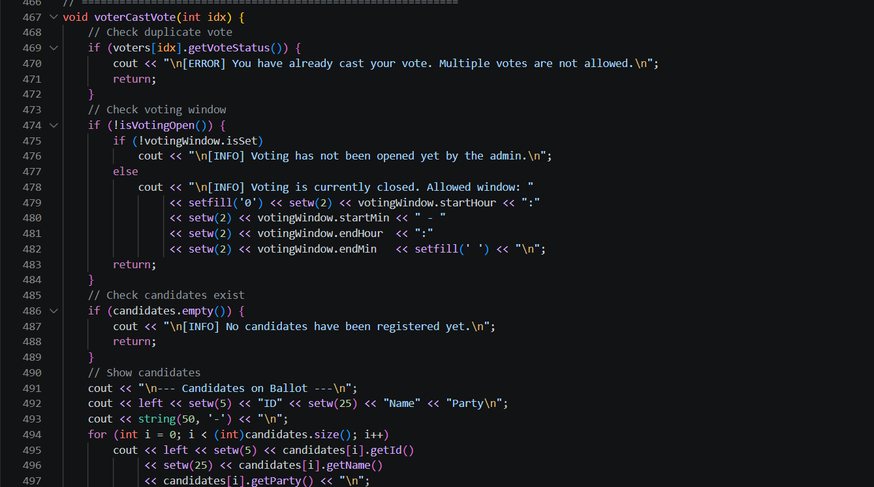Results:
After voting closes, the system calculates the totals and shows the ranked results and charts to the Admin and Voters.

7. GUI Screenshots
Even though the main logic is in C++, we designed a full HTML prototype to show how the final user interface will look.
- Landing Page: This is the main screen where users can choose to log in as a Voter or an Admin or register for a new account.
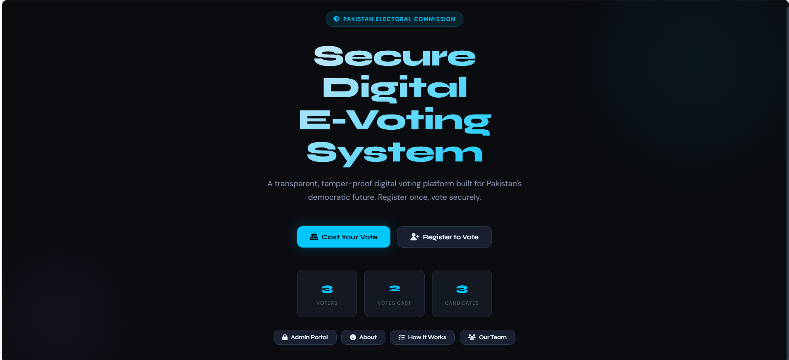
- Registration Screen: This shows the clean form where voters enter their details, featuring clear input boxes.
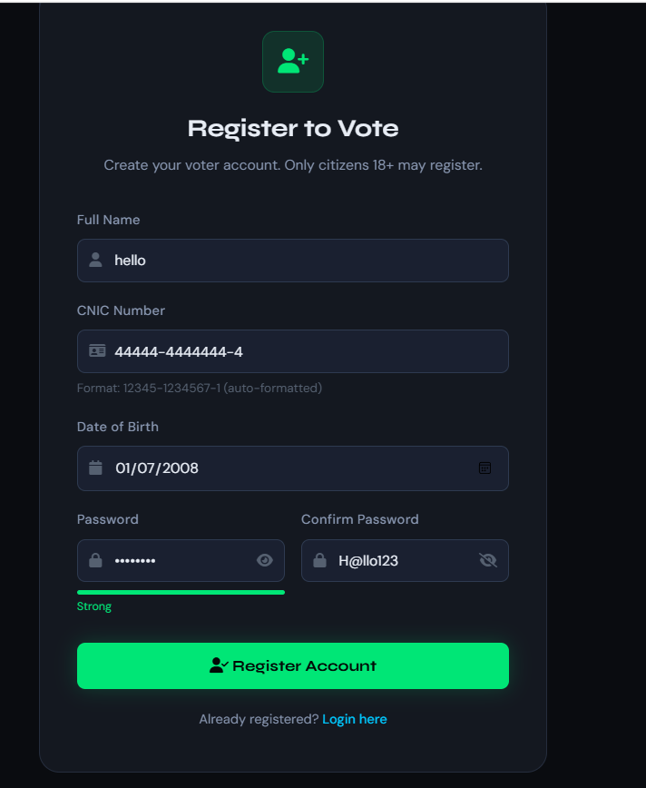

Voter Login:
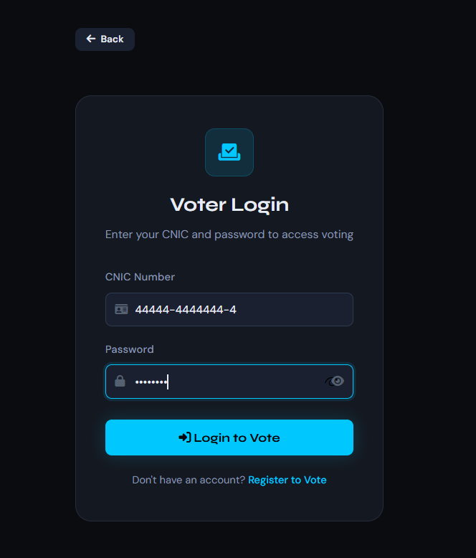

Voting Panel: This is where voters cast their ballots. Candidates are displayed in easy-to-read cards with their names, parties, and election symbols.
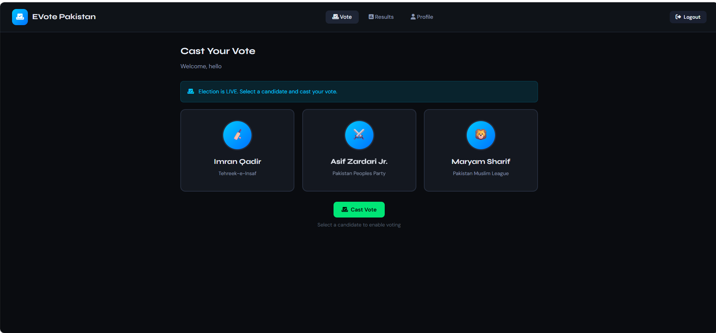
Admin Dashboard: This screen gives election officials a quick look at the total registered voters, the current turnout percentage, and the live election results.
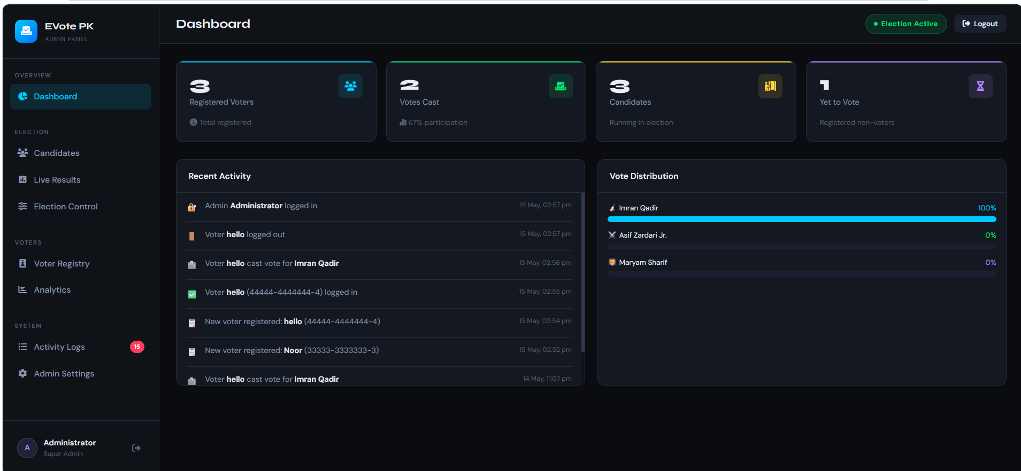

8. Input Validation
We made sure the system handles errors properly, so it doesn't crash if a user types the wrong thing:
- Empty Inputs: We created a readInput() function that uses a while loop to ensure users cannot just press "Enter" and leave important fields blank.
- Password Rules: We wrote a validatePassword() function. If a user tries to set a password, it checks if it is at least 8 characters long, has a capital letter, a number, and a special symbol. If it doesn't, it makes them try again.
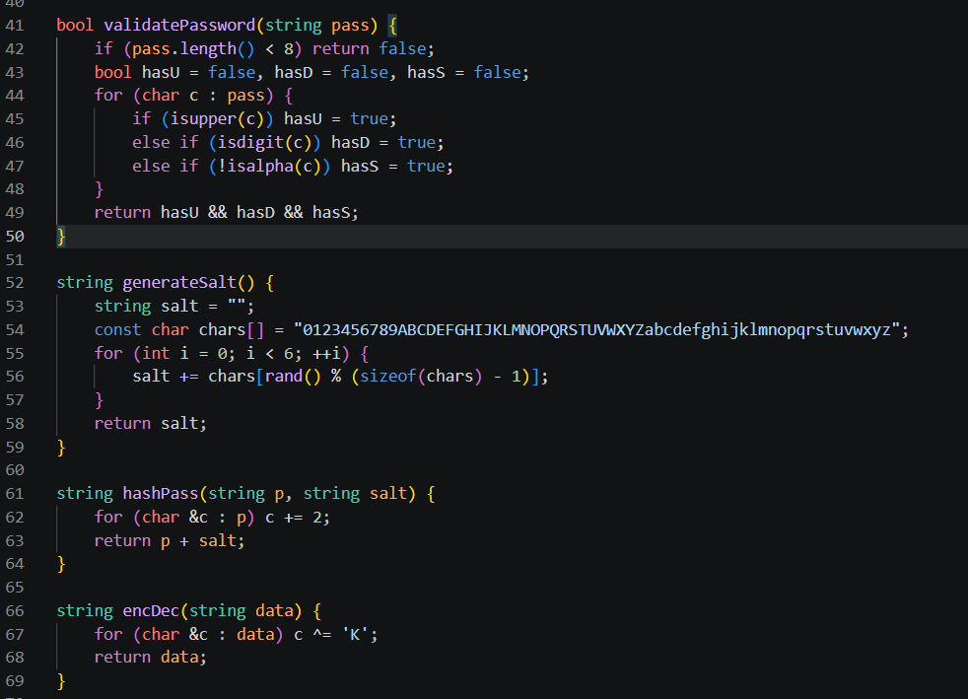Duplicate Accounts: During registration, our isCnicTaken() function checks the database. If someone tries to register with a CNIC that is already in the system, it blocks them.
- Account Lockout: To stop hackers from guessing passwords, the system counts failedAttempts. If a user fails 3 times, their account is locked.

9. Extra Features
We went beyond the basic requirements to add some extra useful features:
- Custom Security (Salting and Hashing): We didn't save passwords as plain text because that is dangerous. We created a system that generates a random "salt" (6 random characters) and mixes it with the user's password before hashing it.
- Data Encryption: We used an XOR cipher to scramble sensitive details like the CNIC and Phone Number before saving them to the text files.
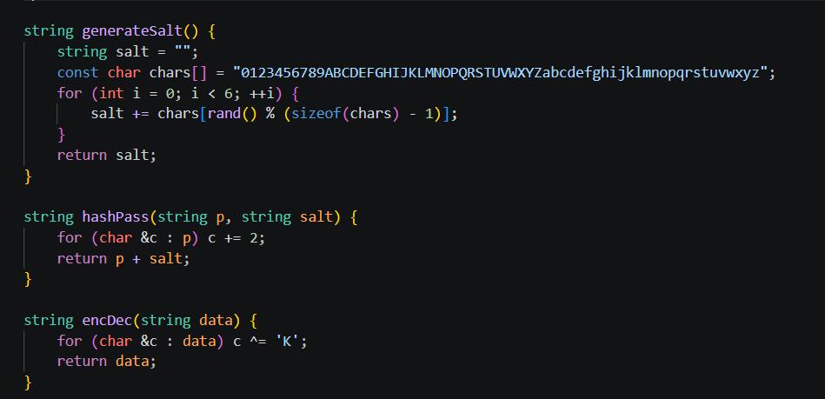Console Data Visualization: Instead of just printing numbers, we programmed the C++ console to draw visual Bar Charts and Pie Charts using ASCII characters (like [==== ]) to show the vote distribution.
- Cryptographic Receipts: When a voter casts a ballot, the system uses the current time to generate a unique receipt ID (like EVOTE-123456). This gives the voter proof they participated without showing who they voted for.

10. Conclusion
The Intelligent Secure E-Voting System (ISEVS) successfully demonstrates how to use C++ and Object-Oriented Programming to solve real-world problems. By using OOP concepts like inheritance and encapsulation, along with strong input validation and encryption, we built a system that protects voter privacy and ensures a fair election.
Future Improvements: In the future, the main goal would be to connect our C++ backend directly to our HTML frontend using a web API framework, so it runs as one complete app. We would also like to upgrade the data storage from text files to a real SQL database to handle thousands of voters more efficiently.

